Motion Graphs
Refer to the following information for the next four questions.

1. Match the description provided about the behavior of a cart along a linear track to its best graphical representation. Remember that velocity is determined by examining the slope of a position-time graph:
- positive slopes represent motion in a positive direction
- negative slopes represent motion in a negative direction
- zero slopes represent an object remaining in one position, that is, at rest

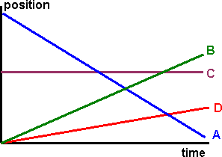
- at rest:

- traveling slowly in a positive direction:

- traveling quickly in a negative direction:

- traveling fast in a positive direction:

Refer to the following information for the next four questions:
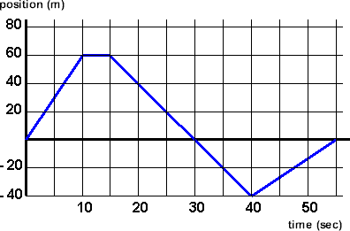
- Given below is a position-time graph displaying the behavior of a race cart along a linear track.

- During which time interval did it first travel in a positive direction?

0-10 sec | 10-15 sec | 15-30 sec | 30-40 sec | 40-55 sec

- During which second time interval did it later, once again, travel in a positive direction?

0-10 sec | 10-15 sec | 15-30 sec | 30-40 sec | 40-55 sec

- During which time interval did it first travel in a negative direction?

0-10 sec | 10-15 sec | 15-30 sec | 30-40 sec | 40-55 sec

- During which second time interval did it continue traveling in a negative direction?

0-10 sec | 10-15 sec | 15-30 sec | 30-40 sec | 40-55 sec

Refer to the following information for the next six questions..
- Velocity is determined by calculating the slope of a position-time graph.
Distance is found by calculation comparing the cart’s position (the graph’s y-axis coordinate) at two times times (the graph’s x0axis coordinate). Distance is a scalar quantity that does not depend on the direction of travel.
- average speed during a time interval is defined as the total distance it traveled divided by the total time taken.

- How far did the cart travel in the first 10 seconds? How fast was it moving during this time interval?

- Briefly describe its behavior between 10 and 15 seconds?

- How far did it travel between 15 and 30 seconds? How fast was it moving during this time interval?

- How far did it travel between 30 and 40 seconds? How fast was it moving during this time interval?

- How far did it travel between 40 and 55 seconds? How fast was it moving during this time interval?

- What was the total distance it traveled? What was its final displacement?

- The coordinates of the turning points are:
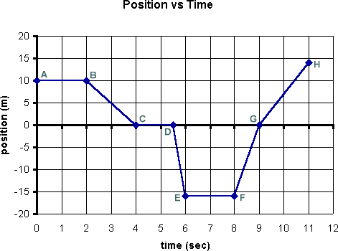

A (0, 10) B (2, 10) C (4, 0) D (5.5, 0) E (6, -16) F (8, -16) G (9, 0) H (11, 14)

  - In which section(s) was the cart traveling at a constant positive velocity?

AB | BC | CD | DE | EF | FG | GH

  - In which section(s) was the cart traveling at a constant negative velocity?
AB | BC | CD | DE | EF | FG | GH

  - In which section(s) was the cart at rest?
AB | BC | CD | DE | EF | FG | GH

  - In which section(s) was the cart located in a positive position?
AB | BC | CD | DE | EF | FG | GH

  - In which section(s) was the cart located in a negative location?
AB | BC | CD | DE | EF | FG | GH

  - What happens at point G?

  - In which section did the cart maintain its greatest average speed? How fast was it traveling?

  - In which section did the cart maintain an average speed of 5 m/sec?

  - In which section did the cart maintain an average speed of 7 m/sec?

  - How far did the cart travel in the first 4 seconds?

  - How far did it travel between 4 and 9 seconds?

  - How far did it travel in the final 2 seconds?

  - What was the cart's total distance traveled during these 11 seconds? What was its average speed?

n. What was the cart's net displacement during these 11 seconds? What was its average velocity?
5.
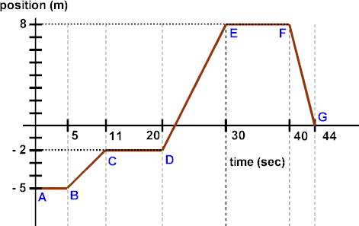

- During which time interval was the cart traveling at its greatest speed?

AB | BC | CD | DE | EF | FG

- During which time interval was the cart traveling at its smallest (nonzero) speed?

AB | BC | CD | DE | EF | FG

- During which time interval(s) was the cart at rest?
AB | BC | CD | DE | EF | FG

- During which time interval(s) did the cart travel in a negative direction?
AB | BC | CD | DE | EF | FG

- What was the cart’s instantaneous speed at 6 seconds?
- What was the cart's instantaneous speed at 22 seconds?

- What was the cart's instantaneous speed at 40 seconds?

- What total distance did the cart travel while moving in a negative direction?

- What total distance did the cart travel while moving in a positive direction?

- What total distance did the cart travel during the entire 44 seconds?

- What was the cart's average speed during the entire 44 seconds?

- What was the cart's net displacement for the entire graph?

- What was the cart's average velocity during these 44 seconds?

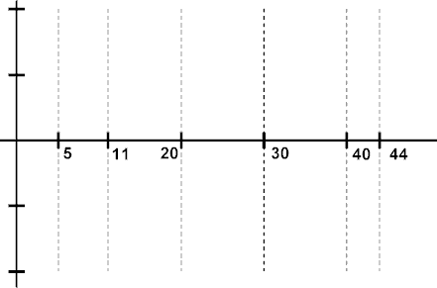
- Construct a velocity-time graph that illustrates this cart's behavior.

6. Refer to the following information for the next three questions.

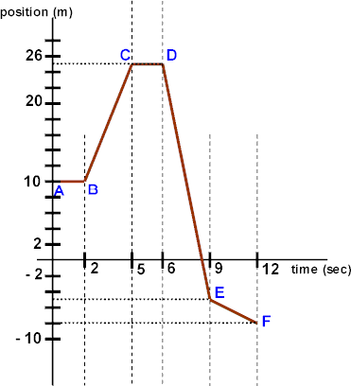

- Sketch a velocity-time graph that corresponds to the position-time graph shown above.

- Calculate the total distance traveled and the object's average speed for the entire 12 seconds

- Calculate the net displacement and the object's average velocity for the entire 12 seconds.
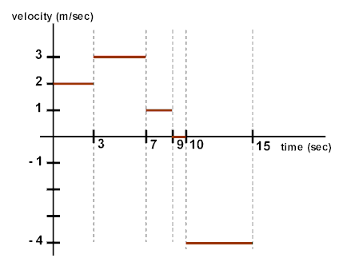
7. Refer to the following information for the next three questions.

  - Calculate the total distance traveled and the object's average speed for the entire 15 seconds.

  - Calculate the net displacement and the object's average velocity for the entire 15 seconds.

  - Sketch a position-time graph that corresponds to the velocity-time graph shown above.

8. Refer to the following information for the next six questions.

Match the description provided about the behavior of a cart along a linear track to its best graphical representation. Remember that:
- velocities are positive when the graph is in I quadrant I
- velocities are negative when the graph is in quadrant IV
- velocity-time graphs sloping towards the x-axis represent losing speed
- velocity-time graphs sloping away from the x-axis represent gaining speed
- the slope of a velocity-time graph represents its acceleration

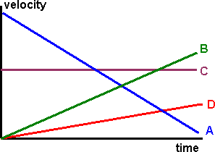

- moving in a negative direction and losing speed

A | B | C | D | no match

- moving in a positive direction and gaining speed at a slow rate

A | B | C | D | no match

- traveling at a steady rate in a positive direction

A | B | C | D | no match

- at rest for an extended time

A | B | C | D | no match

- moving in a positive direction but losing speed

A | B | C | D | no match

- moving in a positive direction and gaining speed at a rapid rate

A | B | C | D | no match

Refer to the following information for the next two questions:

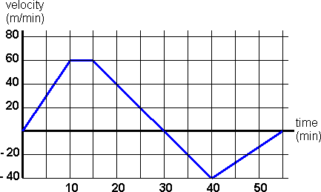
Given below is a velocity-time graph displaying the behavior of a race cart along a linear track.

  - During which time interval(s) did it travel in a positive direction?
0-10 min | 10-15 min | 15-30 min | 30-40 min | 40-55 min

  - During which time interval(s) did it travel in a negative direction?
0-10 min | 10-15 min | 15-30 min | 30-40 min | 40-55 min

Refer to the following information for the next eight questions:
Using the same velocity-graph as in section above, answer these questions regarding how far the cart traveled, its average speeds during each interval, and its displacement. Remember that

Velocity is determined by the height of the graph (the y-axis coordinate). Acceleration is determined by the slope of the graph.
Displacement is found by calculating the area bounded by the velocity-graph and the x-axis. Distance traveled would be the absolute value of each sectional area since it is a scalar quantity. Average speed during a time interval is defined as the total distance it traveled divided by the time taken.

- How far did the cart travel in the first 10 minutes? What was its average acceleration during this time interval?

- Briefly describe its behavior between 10 and 15 minutes?

- What was its average acceleration between 10 and 15 minutes?

- How far did it travel between 15 and 30 minutes? What was its average acceleration during this time interval?

- How far did it travel between 30 and 40 minutes? What was its average acceleration during this time interval?

- How far did it travel between 40 and 55 minutes? What was its average acceleration during this time interval?

- What was the total distance it traveled? What was its final displacement?

- What was the cart's average speed for the entire 55 minutes? its average velocity?

Refer to the following information for the next three questions.

A | B | C

- Each of the following graph shapes is a horizontal line. What general information does this say about the y-axis variable being graphed?

the variable's value is always positive throughout the time interval displayed on the graph
the variable's value is always negative throughout the time interval displayed on the graph
the variable's value remains constant throughout the time interval displayed on the graph - it does not increase or decrease

- Suppose Graph A above represents a position-time graph. Which graph in question #11 would present its correct velocity-time graph?

Graph B | Graph C | none of the original three

- Suppose Graph B above represents a velocity-time graph. Which graph in question #11 would present its correct acceleration-time graph?

Graph A | Graph C | none of the original three

Notes:

Hopefully you have now noticed these two relationships

s-t graph

slope of s-t graph
v-t graph

slope of v-t graph
a-t graph

We define:

  - velocity to be the rate of change of displacement and
  - acceleration to be the rate of change of velocity.

In questions #12 and #13, you determined that when an object's position does not change, its velocity is zero; and when an object's velocity does not change, its acceleration is zero.

Refer to the following information for the next four questions.

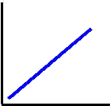
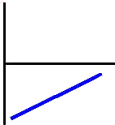
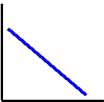
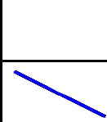

D | E | F | G

- Which of the graph or graphs shown above could represent a velocity-time graph of an object traveling in a positive direction?
Graph D | Graph E | Graph F | Graph G

- Which of the graphs shown above could represent the velocity-time graph for an object uniformly losing speed in a positive direction?
Graph D | Graph E | Graph F | Graph G

- Which of the graphs shown in question #14 would represent the velocity-time graph for an object uniformly gaining speed in a negative direction?
Graph D | Graph E | Graph F | Graph G

- Which graph in question #11 would be the correct acceleration-time graph for both questions #15 and #16?
Graph A | Graph B | Graph C | none would be correct

Notes:

Hopefully you have now noticed this relationship

v-t graph

slope of v-t graph
a-t graph

Since acceleration is the rate of change of velocity (or the slope of a velocity-time graph), an object can experience a positive acceleration by either:

- gaining speed (+) in a positive direction (+) (+) x (+) = (+)
- losing speed (-) in a negative direction (-) (-) x (-) = (+)

Since velocity and acceleration are vectors, the rules of "signed numbers" can assist in remembering when an acceleration will be positive or negative.

No longer can you simply think of acceleration as gaining speed and decelerating as losing speed. You MUST also consider the object's direction of motion.
Refer to the following information for the next five questions.

Use the lesson on graph shapes, to answer each of the following questions about the following position- time graphs.

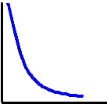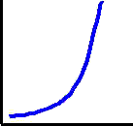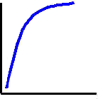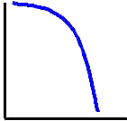

H | I | J | K

- Which graph or graphs show(s) an object moving in a positive direction?
Graph H | Graph I | Graph J | Graph K

- Which graph or graphs show(s) in question #18 an object with a positive acceleration?
Graph H | Graph I | Graph J | Graph K

- Which graph in question #14 could represent a velocity-time graph for Graph J?
Graph D | Graph E | Graph F | Graph G

- Which graph in question #14 could represent a velocity-time graph for Graph H?
Graph E | Graph F | Graph G | Graph H

- Both Graph J and Graph H represent an object uniformly losing speed. Graph J has a negative acceleration while Graph H has a positive acceleration.

True or False: Since acceleration is a vector, the fact that they are traveling in opposite directions reverses the sign.

True | False

Notes:

Hopefully you have now noticed these two relationships

Graphs H and I form the two "halves" of a parabola that opens upward. They represent situations in which the acceleration is positive.

Graphs J and K form the two "halves" of a parabola that opens downward. They represent situations in which the acceleration is negative .

Remember that acceleration can be calculated as the slope of a velocity-time graph. The velocity graphs that correspond to Graphs H and I have positive slopes. While those corresponding to J and K have negative slopes.

Whenever an object is losing speed, its velocity graph moves towards the x-axis (where velocity = zero). When it is gaining speed, its velocity graph moves away from the x-axis to values on the y-axis that represent "greater" speeds.

- The graph below represents the motion of a car.
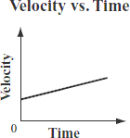

Based on the graph, which of the following statements describes the motion of the car?

A. The car initially travels at a constant speed and then stops.
B. The car starts from rest and then travels at a constant speed.
C. The car starts from rest and then accelerates at a constant rate.
D. The car is initially moving and then accelerates at a constant rate.
- An object is traveling in a straight line. The graph below shows the object’s velocity over time.
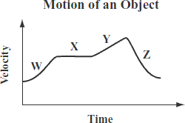

Which line segment shows the object traveling with a constant, positive acceleration?
- The graph below shows the speed of an object during a 10 s time interval.
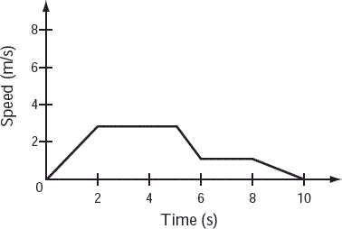

In which of the following time intervals is the speed of the object decreasing?

A. between 0 s and 2 s | B. between 2 s and 4 s | C. between 6 s and 8 s | D. between 8 s and 10 s

